Created by: Christine Mauro

Date created: 03/11/2020

Last Update: N/A

How to display your iPad on your Mac computer. This can be used to make lecture recordings that capture annotations on your iPad. If you want to learn how to use an iPad to annotate your lectures, please see my guide Lecturing with an iPad and Apple Pencil.

1. Connect your iPad to your Mac computer using the lightning to USB cable.
   1. This may automatically open iTunes store - you can close this.
2. Open QuickTime Player on your Mac.
3. In QuickTime, go to File -> New movie recording (It will likely turn on turn on your video camera)

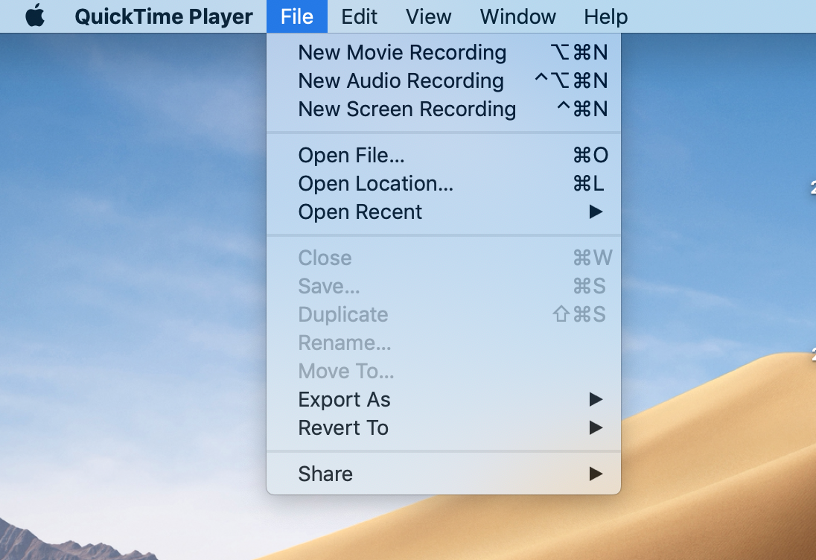

1. Press the down arrow next to the red record button; Under camera, select iPad.

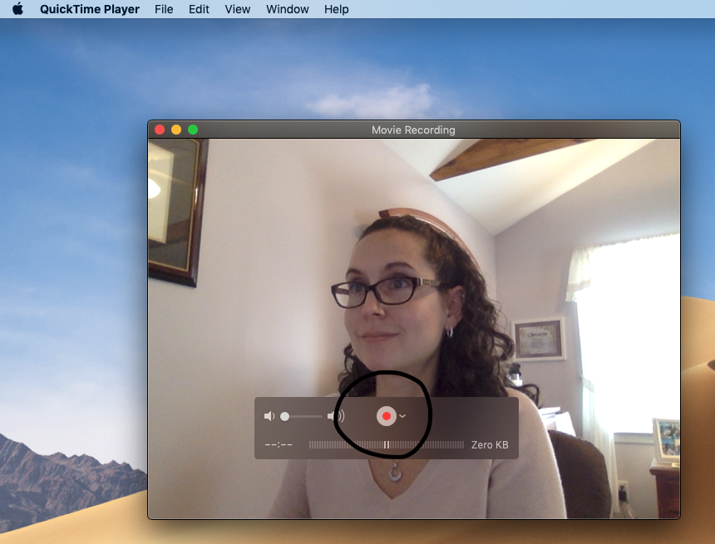

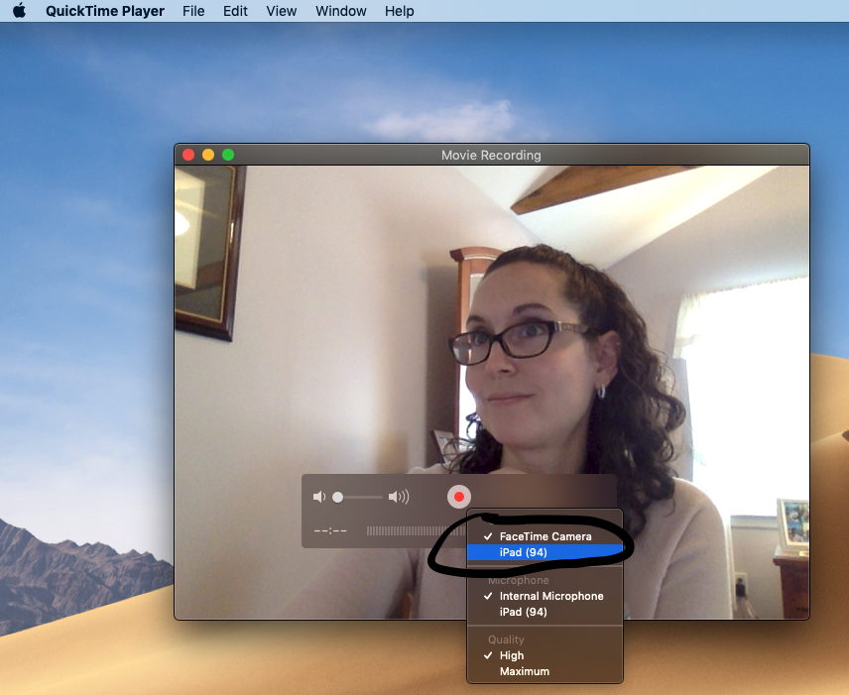

1. You should now see your iPad displayed. Put it in full screen mode.
2. You now have two options:
   1. If you’d like to make a video recording of your iPad + audio, press the red button and start recording. Anything you do on your iPad will be mirrored on your desktop.
   2. If you’re using Zoom and just want to display your iPad (but not record), you don’t need to do anything more in QuickTime. Just “share screen” in Zoom and navigate to the Quicktime Window.
      1. Of course, you could always record AND share to Zoom. I haven’t tested this yet, as I’ll be using the record option via Zoom.